Encapsulation

1. What is Encapsulation?
   * Encapsulation can be used to hide both data members and data functions or methods associated with an instantiated class or object.
2. Encapsulation provides several benefits, such as:
   * **Enhancing security**: Hiding the internal state of objects prevents unauthorized access and manipulation
   * **Easy adaptation:** Encapsulation makes it easier for designers to make changes to the code without risking compatibility. This facilitates successful code evolution over time.
   * **Easier maintenance:** You can develop, test, and debug encapsulated objects independently. Encapsulation can be especially useful in maintaining large data sets.
3. How do you implement encapsulation?
   * “Public” means they're accessible everywhere
   * “private” restricts access within the class
   * “protected” allows access within the same class and its subclasses.

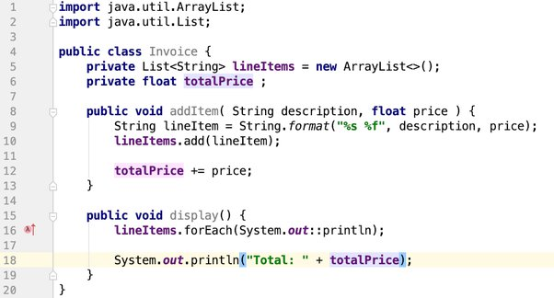

1. Related terms
   * Class
   * Abstraction
   * Data hiding